**MODULE: 5 (JQuery Basic, Effects & Advance)**

**1. What is JQuery?**

* **Ans.** jQuery is a fast, small, and feature-rich JavaScript library. It makes things like HTML document traversal and manipulation, event handling, animation, and Ajax much simpler with an easy-to-use API that works across a multitude of browsers. With a combination of versatility and extensibility, jQuery has changed the way that millions of people write JavaScript.

**2. How to Apply CSS Using JQuery, How to Add Class and Remove Class in JQuery, JQuery Animation?**

* **Ans.**
* **css using Jquery:**

<!DOCTYPE html>

<html lang="en">

<head>

    <meta charset="UTF-8">

    <meta http-equiv="X-UA-Compatible" content="IE=edge">

    <meta name="viewport" content="width=device-width, initial-scale=1.0">

    <title>Document</title>

    <script src="https://ajax.googleapis.com/ajax/libs/jquery/3.6.0/jquery.min.js"></script>

    <script>

        $(document).ready(function()

        {

            $(".b1").click(function()

            {

                $("p").css("background-color","red")

                $("p").css("color","yellow")

            })

            $("div").click(function()

            {

            })

        })

    </script>

</head>

<body>

    <p>Please Change My color</p>

    <button class="b1">css</button>

    <button class="b2">Animation</button>

    <div></div>

</body>

</html>

**Output:**

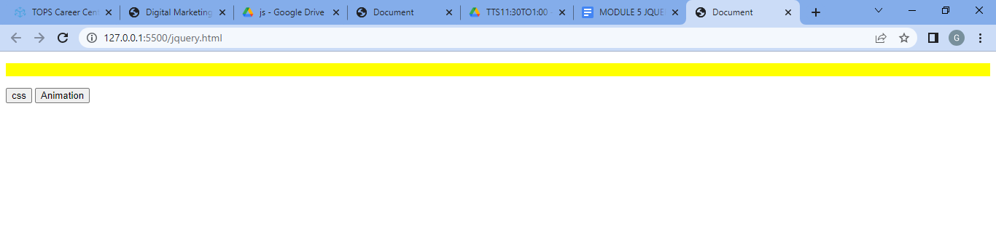

* **Add Class Remove Class:**

<!DOCTYPE html>

<html lang="en">

<head>

    <meta charset="UTF-8">

    <meta http-equiv="X-UA-Compatible" content="IE=edge">

    <meta name="viewport" content="width=device-width, initial-scale=1.0">

    <title>Document</title>

    <script src="https://ajax.googleapis.com/ajax/libs/jquery/3.5.1/jquery.min.js"></script>

    <script>

        $(document).ready(function()

        {

            $(".b1").click(function()

            {

                $("h1").addClass("class")

            })

            $(".b2").click(function()

            {

                $("h1").removeClass("class")

            })

        })

    </script>

    <style>

        .class

        {

            color: blue;

        }

</style>

</head>

<body>

    <h1>

        Comapny Name

    </h1>

    <p>

        Lorem ipsum dolor, sit amet consectetur adipisicing elit. Quidem suscipit eius illum, impedit a culpa delectus ipsum eligendi adipisci, id harum quam, possimus ut eum consequuntur totam ab. Quibusdam, reiciendis?

    </p>

    <button class="b1">Add CSS</button>

    <button class="b2">Remove CSS</button>

</body>

</html>

* **Output:**

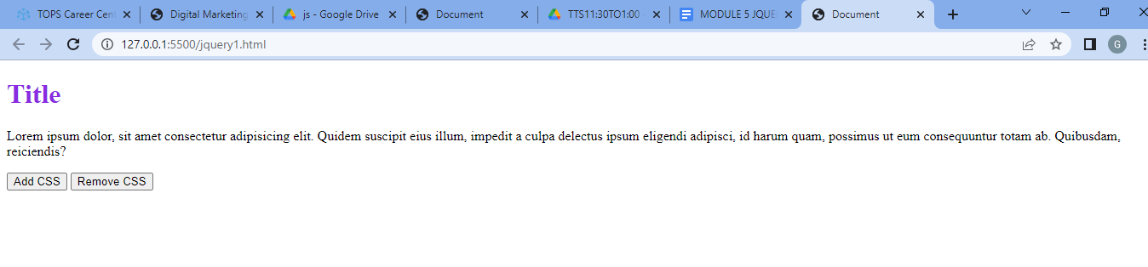

* **jQuery Animation:**

<!DOCTYPE html>

<html lang="en">

<head>

<meta charset="UTF-8">

<meta http-equiv="X-UA-Compatible" content="IE=edge">

<meta name="viewport" content="width=device-width, initial-scale=1.0">

<title>Document</title>

<script src="https://cdnjs.cloudflare.com/ajax/libs/jquery/3.6.4/jquery.min.js"></script>

<!-- style -->

<style>

#myDiv {

width: 200px;

height: 200px;

background-color: rgb(196, 180, 12);

}

</style>

</head>

<body>

<h1>jQuery Animation Example</h1>

<div id="myDiv"></div>

<script>

// jQuery code starts here

$(document).ready(function () {

var $myDiv = $("#myDiv");

// Define the animation

$myDiv.click(function () {

$myDiv.animate({

width: "400px",

height: "400px",

backgroundColor: "blue"

}, 1000, function () {

// Animation complete

$myDiv.animate({

width: "200px",

height: "200px",

backgroundColor: "red"

}, 1000);

});

});

});

</script>

</body>

</html>

* **Output:**

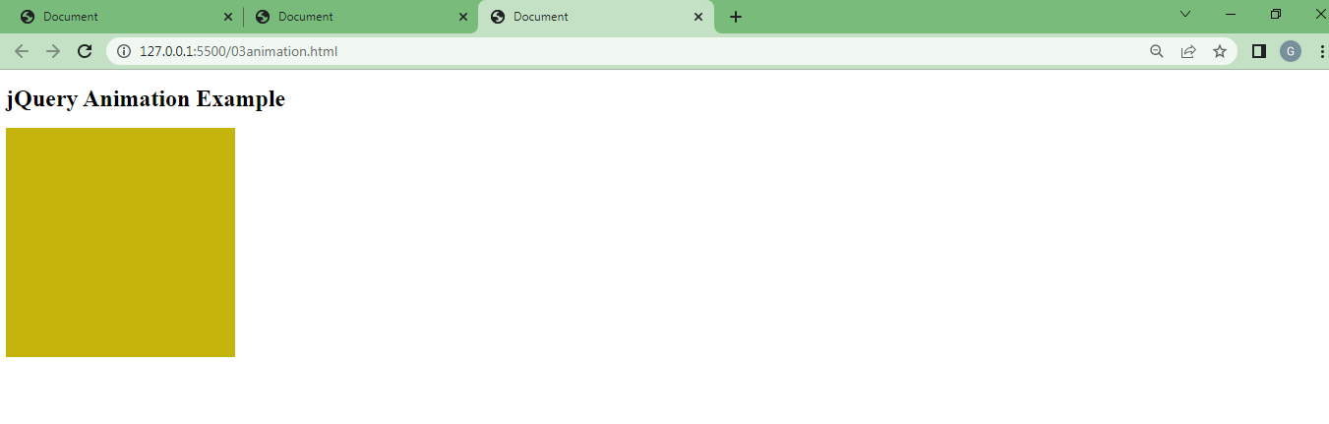

**3. How to create slider with animation?**

* **Ans.**
* JQuery animate () method
* The method used to create custom animations called the JQuery animate () method. This type of method used to animate CSS properties , like, width, height, margin, opacity, top, left and padding.

**Example:**

* **Input:**

<!DOCTYPE html>

<html lang="en">

<head>

<meta charset="UTF-8">

<meta http-equiv="X-UA-Compatible" content="IE=edge">

<meta name="viewport" content="width=device-width, initial-scale=1.0">

<title>Document</title>

<script src="https://cdnjs.cloudflare.com/ajax/libs/jquery/3.6.4/jquery.min.js"></script>

<!-- style -->

<style>

.slide{

height: 250px;

width: 200px;

background: yellow;

margin: 10px;

}

</style>

</head>

<!-- html -->

<body>

<div id="slider">

<div class="slide">Slide 1</div>

<div class="slide">Slide 2</div>

<div class="slide">Slide 3</div>

</div>

<!-- script -->

<script>

$(document).ready(function () {

var slider = $('#slider');

var slides = $('.slide');

var currentIndex = 0;

// Set the initial slide

slides.eq(currentIndex).show();

// Function to animate the slides

function animateSlides() {

// Fade out the current slide

slides.eq(currentIndex).fadeOut();

// Increment the index

currentIndex++;

// Wrap around to the first slide if necessary

if (currentIndex >= slides.length) {

currentIndex = 0;

}

}

// Set an interval to animate the slides every 5seconds

setInterval(animateSlides, 5000);

});

</script>

</body>

</html>

* **Output:**

